Blog Post: We Need to Intervene Before Childcare Costs Strangle our Economy
No issue is more on the minds of everyday American than the economy. We attentively watch the stock market rise and fall. We groan about grocery prices increasing. With most Americans living paycheck to paycheck, there is little wiggle room in anyone’s budget. Any factor that is poised to disrupt our economy is an issue of critical importance for us all.
One area of society where costs are especially severe is for families with young children. As a percentage of median income, the costs for childcare for even one child are extreme. If the recommendation is that housing costs 25% of your budget, childcare for two children costs more than housing in most parts of the country.
But childcare costs are not just an issue for families with young children. Higher costs contribute to higher unemployment, particularly for females with children under the age of six who need childcare the most. Higher unemployment stifles the economy for everyone. And the data shows that costs are continuing to rise even as demand decreases. This situation is getting more imbalanced every year, and it threatens to spill over and affect all of us.
Let me walk you through the situation step by step and then circle back to what we can do about it. First off, let’s look at how much childcare costs. Because income varies so much throughout the country, I scaled childcare costs for children under six by the median family income. This allows us to look at childcare costs as a percentage of an average family’s income and this is what we see:
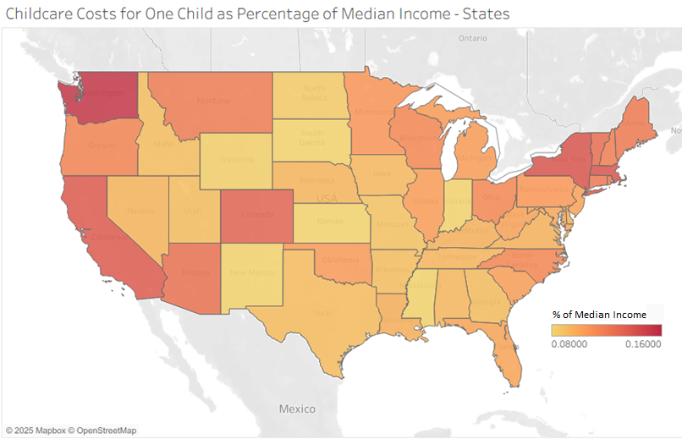
More than half the country has childcare costing more than 10% of median income. These high costs mean that women with children under six are much less likely to work than women with children in general.
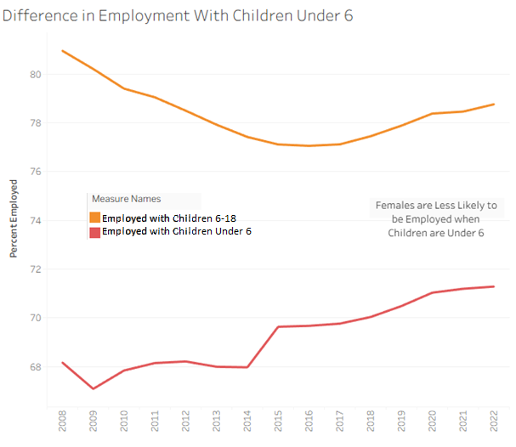
Higher employment would drive up median family income, reducing the portion of family income that needs to be spent on childcare. And this is exactly what is happening in reverse. As childcare costs increase, employment decreases, and childcare costs take up more and more of a family’s income.
What’s more this is not the only imbalanced issue at play. For reasons I couldn’t uncover through my research so far, costs are continuing to increase even as demand (family with children) decreases. This means that, for families with children, this situation is accelerating and getting worse.
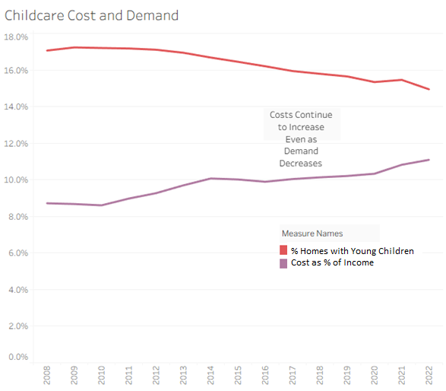
We’ve now established the scope of the problem, the dynamics that drive it, and the fact that this situation is trending towards increasing instability. Intervention is necessary, but we aren’t realistically going to be able to solve it all at the same time. Thankfully, the data provides some clear indicators of where we can start.
We can extend our calculation of childcare costs as a percentage of median family income by factoring the percentage of homes with young children. This allows us to derive an impact score where the issue is both severe and widespread. While this bears a lot of similarities to our earlier map, it has some key differences that show us the benefit of adding in this additional element. Here is a map that shows where childcare cost reduction would have the greatest impact:
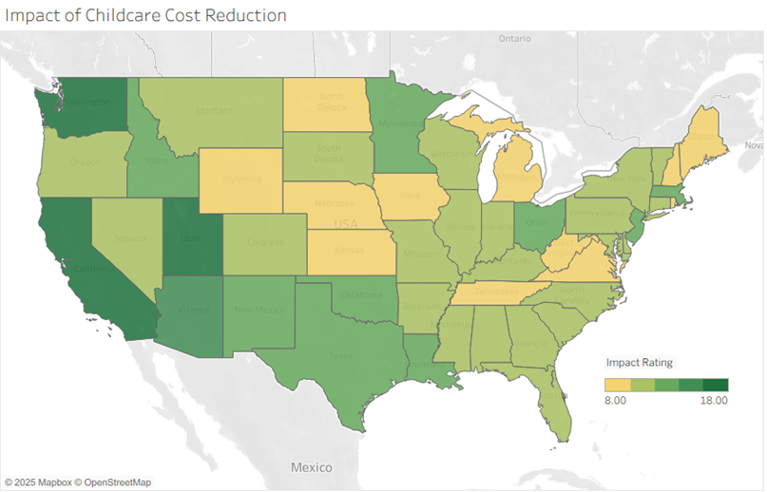
California, Washington, and Arizona stay elevated between the two maps, but most other states experience a shift due to factoring in the percentage of families with young children. This allows us to target states where a cost reduction program would affect the greatest number of people as well as the most impacted individuals. In particular, these are the top states where interventions would have the greatest impact:
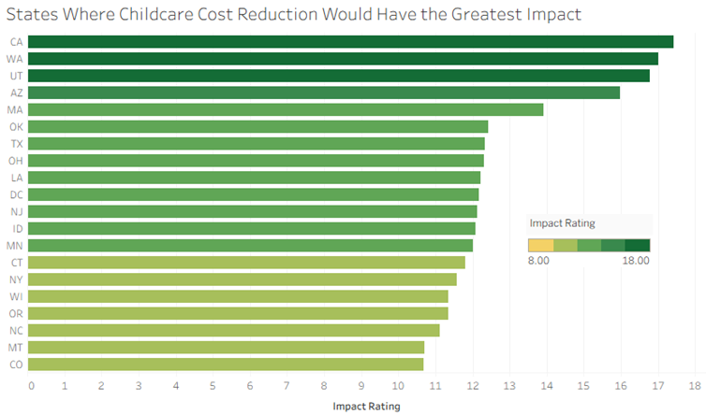
It is easy to encounter a problem like this and feel overwhelmed, but the data shows us clearly where to start addressing this problem. If we start in a few areas first, we can learn more about this situation as we go. Along the way, millions of families will be impacted for the better, and whole communities will receive the benefits of higher employment and increased median income. It’s not too late to step in and address this issue, but we need to take action now before the situation gets much worse.

